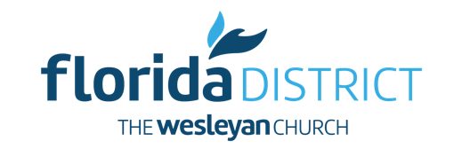
Florida District of The Wesleyan Church
Disaster Relief
Volunteer Application

Date________________ Full Name ________________________________________________

Address ______________________________________________________________________

City ___________________________________ Florida, Zip Code ______________________

Phone __________________________E-mail ________________________________________

Emergency Contact Name ______________________________ Phone ____________________

Church’s Name ____________________________________ Pastor’s Name ________________

Please circle your interests in participation:

Electrical Tree/debris clearing Roofing
Carpentry Construction Handyman
Cooks Medical professional Mechanics
Others ______________________

If you have participated in any disaster relief project in the past, please describe your experience:

______________________________________________________________________________

______________________________________________________________________________

Do you have any physical or medical disabilities that would hinder your involvement? If so, please explain:

_____________________________________________________________________________

______________________________________________________________________________

If sent to a disaster area, please indicate below the duration you would be able to participate:

___ one week ___ two weeks ___one month

Please list any additional information we should know about your background or qualifications:

______________________________________________________________________________

______________________________________________________________________________
Please mail, email or Fax your applications to: The Florida District of The Wesleyan Church
3807 Maryweather Ln
Wesley Chapel, FL 33544
Fax: (813) 907-5522
Email: do@floridawesleyan.com

